Alan Yu

Organic Lab 309:03

Santanu Malakar

Experiment 30: Synthesis of Triphenylmethanol and the Trityl Carbocation

April 15, 2019

**Purpose:**

To synthesize Triphenylmethanol and the Triphenylmethanol and the Trityl Carbocation.

**Equations:** (from textbook and lecture)

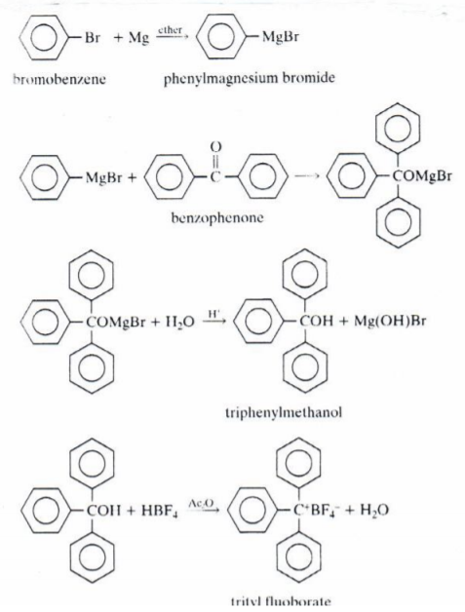

**Mechanisms:**

**Amounts and Properties:**

Table 1: Important properties and amounts for experiment

| **Chemicals** | **Mol Wt** | **MP** | **BP** | **D** | **Amounts** |
| --- | --- | --- | --- | --- | --- |
| Bromobenzene | 157 | -31 | 156 | 1.495 | 22 mmol |
| Magnesium | 24.3 |  |  |  | 22 mmol |
| Diethyl Ether | 74.1 | -116 | 34.5 | .714 | 21.5 mL |
| Benzophenone | 182.2 | 48 | 306 |  | 20 mmol |
| Triphenylmethanol | 260.3 | 164 | 380 |  |  |
| Fluoboric Acid | 87.8 |  |  | 1.41 | 1 mL |
| Acetic Anhydride | 102.1 | -73 | 140 | 1.082 | 7 mL |
| Trityl Fluoborate | 330.1 |  |  |  | 1 g |
| HCl |  |  |  |  | 15 mL |
| Sodium Bicarbonate |  |  |  |  | 15 mL |
| Sat. Sodium Chloride |  |  |  |  | 15 mL |

**Hazards and Safety:**

Bromobenzene causes eye and skin irritation; inhalation, ingestion, or skin absorption may be harmful. Avoid contact with liquid and do not breathe vapors. Diethyl ether is extremely flammable and may be harmful if inhaled. Do not breathe its vapors and keep it away from flames and hot surfaces. Magnesium can cause dangerous fires if ignited and keep away from flames and hot surfaces too. Petroleum ether is extremely flammable and may be harmful if inhaled or absorbed through the skin. Avoid inhalation and prolonged contact and keep it away from flames and hot surfaces. Acetic anhydride can cause severe damage to skin eyes. Its vapors are very harmful if inhaled and reacts violently with water. Use gloves and keep it under the hood, away from water, do not contact it or breathe the vapors. Fluoboric acid is poisonous and corrosive and its solutions can cause severe damage to skin and eyes, and its vapors irritate respiratory system. Use gloves and hood and avoid contact with solutions made and don’t breathe its vapors. Carefully handle HCl, NaCl, and Sodium Bicarbonate and do not breathe vapors. Dispose of all chemicals in labeled containers under the hood.

**Procedure:**

**Part A: Prep of Triphenylmethanol**

Adding magnesium to the bromobenzene creates a Grignard reagent that will be able to react with the diethyl ether that will be added. Using a hand to warm the system instead of the heating mantle is to prevent the solution from boiling since the boiling point of the ether is 34.5 degrees Celsius. Adding drop by drop is to ensure the reaction has gone through thoroughly instead of sloppily.

**Reaction of Phenyl Bromide with Benzophenone:**

After creating the phenyl bromide, the addition of benzophenone allows for the phenyl bromide to attack the carbonyl in the benzophenone. Adding water in any acidic solution reacts with the triphenyl bromide and creates both triphenyl methanol and a basic bromide.

**Separation:**

Removes all excess magnesium in the solution that was created so that these solid impurities wouldn’t stay throughout. Washing is to also used to remove impurities that could be present within the organic layer that was going to be kept.

**Part B: Prep of Trityl Fluoborate:**

Using a strong acid within the solution to create a carbocation allows for the strong acid which creates a weak nucleophile to not react with the cation again thus creating the precipitate, the carbocation, that was sought after.

**Observations:**

During the experiment when the magnesium was added with the bromobenzene the solution that was created looked like decarbonated coke. After refluxing further and adding the Benzophenone, the solution changed to a reddish-pink in color. As the reaction continued the solution resembled that of pepto bismol in color and when water and HCl was added, the solution slowly changed to a clear yellow solution. When rotovapping, the solid that was created was a darkish yellow in color. After adding the hexanes to the rotovapped sample, the sample became a white cloudy solution. During the first recrystallization process, the solid that was created was whitish in color. Using the methanol created, after adding the fluoroboric acid to the solution, the solution changed to a dark orange color. During the color change gas was also created and a lot of heat was released. While trying to recrystallize for the cation, the cation did not recrystallize. This was either due to an excess addition of the solutions used to create the cation, or adding the wrong compounds for the solution. During some testing to see if the cation was actually made, water was added and there was a reaction towards the water that slowly removed the orange color which proved that some compound was created from the experiment.

**Measurements:**

Table 2: Amounts used during the experiment

| Magnesium Used: .537g | Bromobenzene used: 3.454g |
| --- | --- |
| Benzophenone Used: 3.654g |  |
| HCl used: 15 mL | Water Used: 5 mL |
| Triphenylmethanol Gained: .758g | Trityl Carbocation Gained: 0g |

**Data and Calculations:**

Limiting reagent was Benzophenone:

$.02 mol Benzophenone * \frac{260.3g}{1 mol} = 5.206g Triphenylmethanol$

$\frac{.758g}{5.206g} =.1456 * 100 = 14.56\% yield$

**Discussions:**

0% yield of the carbocation could indicate that the reagent that was used to create the carbocation had water. Due to the low percent yield of 14.56% a possible error could’ve been that the reaction flask was not completely dry so some of the product created after the first step would’ve reacted with water and ruined the reaction. Throughout the experiment, the ether kept evaporating whenever there was a pause for the experiment to prepare a different section. Specifically, there was a pause while filtering out the magnesium which could lead to the loss of a lot of product due to the rate of the ether evaporation. This clogged the filter which could’ve had some of the product stuck on the filter paper and harder to retrieve all of it without any impurities.

**Conclusions:**

Since the percent yield of the trityl carbocation was 0, it can be concluded that there was either not enough time for the crystal to form or the reaction was not done due to there being water within the reaction flask. Since there was a 14.56% yield, the reaction setup was most likely wet which caused products to react with the water, thus ruining the yield.

**Exercises:**

1. A. 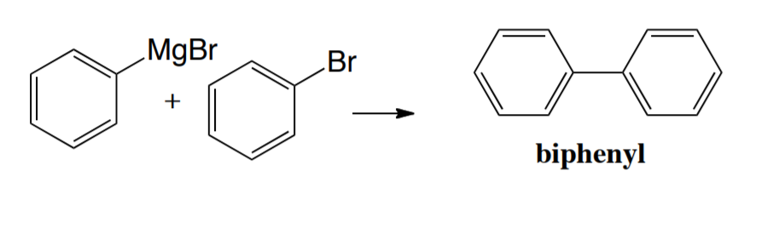

B.

3. A. If solvent-grade diethyl ether was used, the product that will be formed can react with water thus creating a benzene and rendering the experiment useless. B. If the ether was not added to the reaction, the Grignard product would form since ether is an important part of the Grignard reaction. C. Using the diethyl ether will allow the biphenyl impurities to stay and not allow them to be separated without other means of extraction.

6.

7.

Synthesis of 1,1-diphenylethanol:

1. React a benzene with Br2 in AlBr3 to create bromobenzene.
2. React the bromobenzene with Mg in anhydrous ether to make the Grignard reagent.
3. React the Grignard reagent with acetophenone created by benzene with CH3COCl with AlCl3 and acid workup and this creates the product.

Synthesis of 1,2-diphenylethanol:

1. React a benzene with Br2 in AlBr3 to create bromobenzene.
2. React the bromobenzene with Mg in anhydrous ether to make the Grignard reagent.
3. React the Grignard reagent with 2-Phenyloxirane followed by an acid workup to create the product.

Synthesis of 2,2-diphenylethanol:

1. React a benzene with Br2 in AlBr3 to create bromobenzene.
2. React the bromobenzene with Mg in anhydrous ether to make the Grignard reagent.
3. React Grignard reagent with 2-Phenyloxirane in acid to attack the more substituted carbon followed by acid workup to create product.

Synthesis of 2,3-diphenyl-2-butanol:

1. React a benzene with Br2 in AlBr3 to create bromobenzene.
2. React the bromobenzene with Mg in anhydrous ether to make the Grignard reagent.
3. React the Grignard with a methylium and follow it with an acid workup to create the product.